**Gulp setup**

1. In order to set up gulp you have to make sure you have THE LATEST VERSION OF [nodejs](https://nodejs.org/en/) and npm installed on your PC. Type “*node –v*” to get current version of the node.js. After you install nodejs you should also be able to do “*npm -v*” to get the current version of npm (node package manager).
2. Create the folder where you are going to work in. Find it in your cmd and initialize npm to set up the project using “*npm init*” and follow the instruction.
3. First time you would like to use gulp you have to install it in your cmd using “*npm install -g gulp*”
4. After we init our project we have to add node_modules (gulp) in order to keep track of all our dependencies we need for the project. Type “*npm install –-save-dev gulp*”.

**SASS gulp method**

In order to use “sass” method you have to import sass module using “*npm install --save-dev gulp-dart-sass*” in cmd and require that module in your gulpfile.js. like this *var sass = require( 'gulp-dart-sass' );*

**Sourcemaps gulp method**

In order to use “sourcemaps” method you have to import sass module using “*npm install --save-dev gulp-sourcemaps*” in cmd and require that module in your gulpfile.js. like this  *var sourcemaps = require( 'gulp-sourcemaps' );*

**Autoprefixer gulp method**

In order to use “autoprefixer” method you have to import sass module using “*npm install --save-dev gulp-autoprefixer*” in cmd and require that module in your gulpfile.js. like this *var autoprefixer = require( 'gulp-autoprefixer' );*

**Rename gulp method**

In order to use “rename” method you have to import rename module using “*npm install --save-dev gulp-rename*” in cmd and require that module in your gulpfile.js. like this *var rename = require( 'gulp-rename' );*

**Standard folder structure**

For the standard file structure create a src (source) and dist (distribution) folders inside your project with needed folders in them src > scss, js, dist > css, js. Src will contain source files (scss and es6 js) and we will automatically compile files from src and save them into dist. So, we have to create style.scss inside src > scss and script.js inside src > js. Here is an example of folder structure

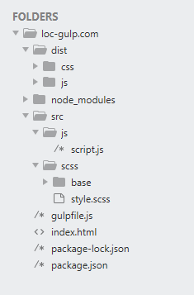

**Creating first task**

When you have support of needed packages and set you folder structure you can create a first task.

To create the first task you need to have main gulp file called guilfile.js in root of your project where you will specify a list of tasks that have to be done. Gulp is all about tasks

Inside it you have to require all dependencies – packages that you installed above

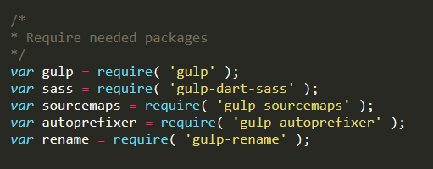

Let name the first task “style”. It will compile and minify scss file and save it into vanilla css file. Example of the “style” task.

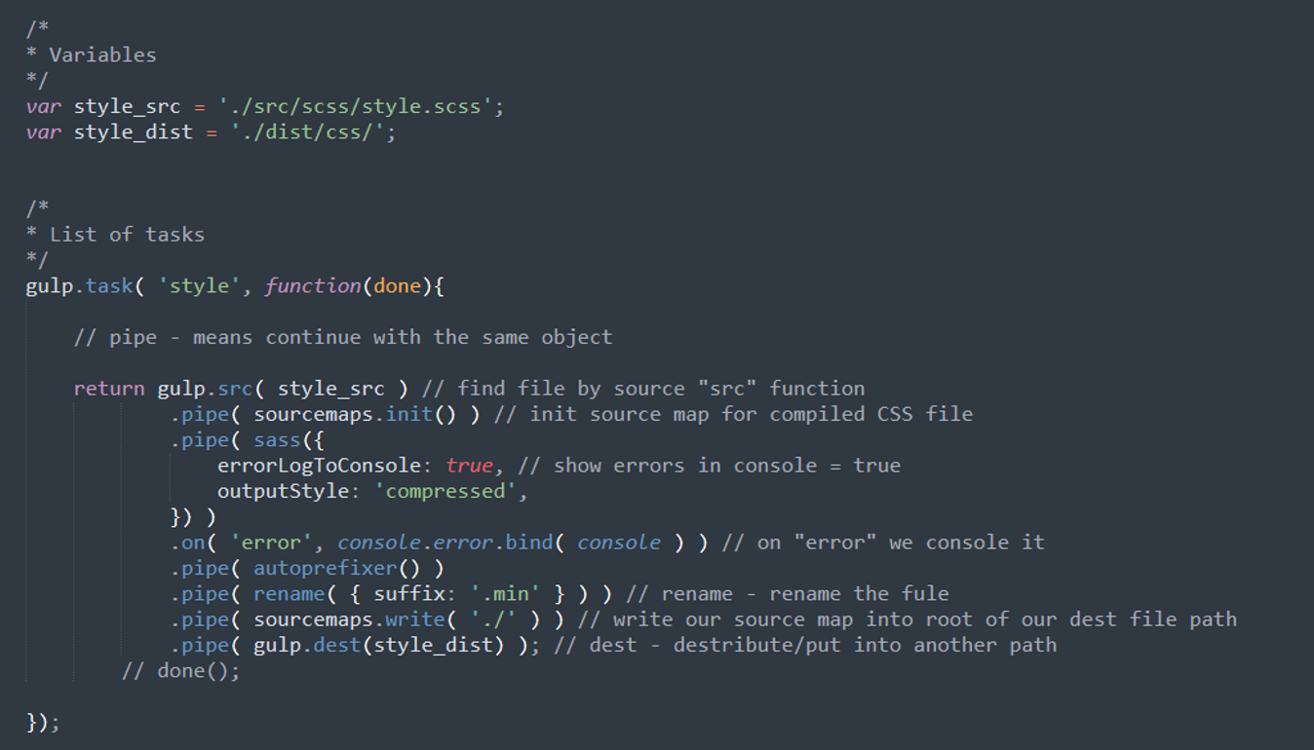

In order to run this task you have to write “gulp NAME_OF_THE_TASK”, in our case it will be “gulp style”

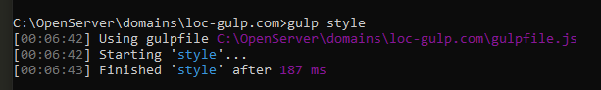

**Watch and default tasks**

Gulp comes with a default task that run all tasks that are assigned to it.

Also, we can watch for changes in files/folders and trigger some tasks. For this we have to create a “watch” task and trigger all tasks that we want to activate (we will use the default one and trigger all tasks to it).

